When Preview not Shown:

(Mainly it is occurred when use Fire fox)

Step 1: Click Firefox Menu tools.

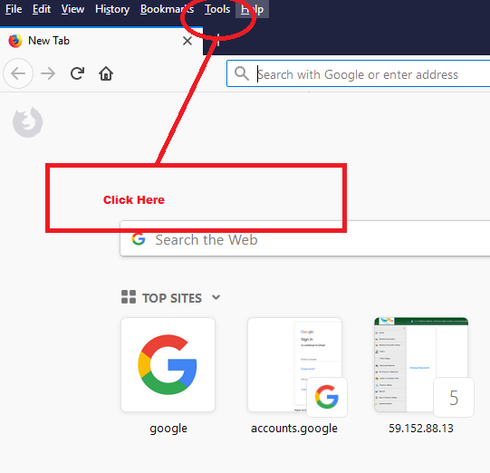

Step 2: Click Options

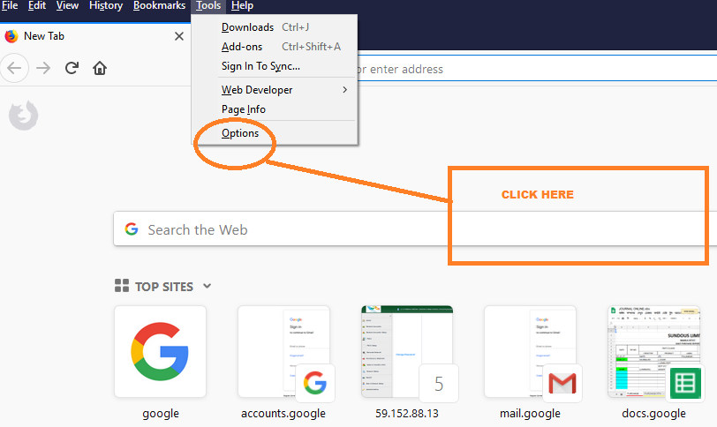

Step 3,4 & 5:

Click as following.

>Applictions

>Portable Document formate (PDF)

>Preview in FireFox

